Structure and function of cells in a neural integrator

Ashwin Vishwanathan, Kayvon Daie, Alexandro D. Ramirez,

Jeff W Lichtman, Emre Aksay, and H. Sebastian Seung

Neuroscience Institute and Computer Science Department

Princeton University, Princeton, NJ 08544

Institute for Computational Biomedicine and

Department of Physiology and Biophysics,

Weill Cornell Medical College, New York, NY 10021

Department of Molecular and Cellular Biology and Center for Brain Science,

Harvard University, Cambridge, MA 02138

**Abstract**

Neural integrators are involved in a variety of sensorimotor and cognitive behaviors. The oculomotor system contains a simple example, a hindbrain neural circuit that takes velocity signals as inputs, and temporally integrates them to control eye position. We combined observations of behavior, physiology, and anatomy to study integrator neurons. To understand the mechanisms of integration, here we performed ultra-structural analysis of functionally-identified neurons located in the neural integrators. Two-photon calcium imaging of the larval zebrafish hindbrain was performed while simultaneously monitoring spontaneous eye movements. Integrator neurons were identified as those cells with activities highly correlated with eye position, and the same neurons were then reconstructed from serial electron microscopic images. Three major morphological classes of cells were observed: ipsilaterally projecting cells located medially and rostrally, contralaterally projecting cells located more laterally and caudally, and a population at the extreme lateral edge of the hindbrain for which we were not able to identify axons. Based on previous reports of correlation between somatic location and neurotransmitter identity, we infer that cells with only ipsilaterally projecting axons are largely glutamatergic and excitatory, whereas cells with only contralaterally projecting axons are largely GABAergic and inhibitory. We observed the first conclusive evidence of synapses between integrator neurons, from an ipsilaterally projecting cell onto other cells. These results support the idea of integration through positive feedback by recurrent excitation and mutual inhibition.

## 1 Introduction

The larval zebrafish has become an important model organism for investigating the relation between neural circuits and behavior (Friedrich et al., 2010). Neural activity has been observed via two-photon calcium imaging and correlated with a variety of behaviors (Ahrens et al., 2012). Here we extend this approach by combining two-photon calcium imaging of neurons in a behaving fish with subsequent reconstructions of the same neurons using serial electron microscopy. The behavior is spontaneous eye movements, and the neurons are in a hindbrain neural circuit known as the "velocity-to-position neural integrator," or "neural integrator" for short (Major and Tank, 2004; Joshua and Lisberger, 2015).

Integrator cells are operationally defined as premotor neurons that carry a horizontal eye position signal in their spiking. (There is also an integrator for vertical eye movements, but it will not be discussed here.) Integrator cells are thought to send their eye position signals through direct synapses onto extraocular motor neurons in the ipsilateral abducens nucleus. They are also thought to receive signals from multiple convergent pathways that encode eye velocity for every type of eye movement. Therefore, the neural integrator is the “final common pathway” for all types of eye movements in fish (Pastor et al., 1994; Aksay et al., 2000, 2001), rodents (van Alphen et al., 2001), non-human primates (Robinson, 1989; Newcombe, 2008), and humans (Leigh and Zee, 2015). The neural integrator gets its name because the transformation of eye velocity into eye position is the computational operation of integration with respect to time.

Previous attempts to understand how the integrator transform a ’pulse’ like input to a ’step’ like output have depended on assumptions about the structure of the underlying neural circuit. For example, it has been proposed that integration can be supported by recurrent excitation between neurons on the same side of the brain (Kamath and Keller, 1976; Seung, 1996; seung\s\do5(s)tability\s\do5(2)000; Fisher et al., 2013), and/or mutual inhibition between populations on opposite sides of the brain (Cannon et al., 1983; Arnold and Robinson, 1997). Evidence arguing for the role of the underlying structure come from structure-function studies where intracellular recording were performed to identify goldfish hindbrain neurons exhibiting spiking correlated with eye position (Aksay et al., 2000), followed by anatomical dye fills of integrator neurons, showing axons of these cells to send collaterals to areas where other integrator cells were observed. A second method relied on two-photon calcium imaging to identify zebrafish integrator neurons with eye position signals (Lee et al., 2015). These were targeted for single cell electroporation of a fluorescent indicator and reconstructed. Both of these studies relied on light microscopy for structural information. As a result, they were limited to one or a few neurons in any individual brain, and could not positively identify synapses. Similar anatomical observations have been observed in cats (McCrea and Baker, 1985) and nonhuman primates (Steiger and Bьttner-Ennever, 1979).

Although, these collaterals could potentially contact dendrites of other integrator neurons, conclusive evidence for contact and synapses has been lacking. This paper applies serial section electron microscopy (EM) to yield improved structural information about many integrator neurons from a single animal.

Integrator neurons were identified in the hindbrain of a larval zebrafish using two-photon calcium imaging while recording spontaneous saccadic eye movements. The same neurons were located in the EM dataset, and their neurites were completely reconstructed within the confines of the imaged volume. We identified chemical synapses in our images by the existence of presynaptic vesicles and postsynaptic densities. All chemical synapses involving integrator neurons contained small vesicles, suggesting the presence of conventional rather than peptidergic neurotransmitters. We found three major groups of cells within the integrator population. Cells with ipsilaterally projecting axons, identified by the existence of presynaptic boutons containing vesicles, cells with only contralaterally projecting axons, identified by a distinctive glial ensheathment near the midline. Both axonal projection patterns are consistent with a previous report based on light microscopy (Lee et al., 2015). In addition, we found cells at the lateral most edge of the volume, for which we could not identify an axon and two integrator neurons with axonal arbors that were both ipsilateral and contralateral, which has not been previously reported .

We found one example of an ipsilaterally-projecting integrator neuron that made two synapses onto another ipsilaterally-projecting integrator neuron. The same source neuron also synapsed onto two contralaterally-projecting integrator neurons. This provides the first evidence that integrator neurons make synapses onto each other. Finally, we interpreted the neurotransmitter identity of the cells, as organized into “stripes,” of somata, that are correlated with neurotransmitter identity (Higashijima et al., 2004; Kinkhabwala et al., 2011; Koyama et al., 2011). On this basis, we inferred that integrator neurons with only ipsilaterally projecting axons are glutamatergic, and those with only contralaterally projecting axons are GABAergic.

We note that two-photon calcium imaging and serial electron microscopy have been successfully combined in the mouse retina (Briggman et al., 2011) and primary visual cortex (Bock et al., 2011; Lee et al., 2016). Our work is the first application of this approach to a population of neurons defined by their encoding of behavioral variables, rather than stimulus variables.

## 2 Results

### 2.1 Identification of integrator cells by two-photon calcium imaging

Calcium signals were correlated with eye position to identify integrator somata from the imaged planes (Fig. 1A) (Miri et al., 2011b). If saccade-triggered average fluorescence was correlated strongly with saccade-triggered eye position (Pearson coefficient >0.6), the cell was identified as an integrator neuron (Fig. 1A - b). These cells have distinct, graded persistent firing during eye fixation, as seen by the average of the fluorescence response, following the saccade, during the post-saccadic fixation period (Fig. 1A- c, see methods). Average saccade-triggered responses of these cells show cells with a range of persistence times. Cells with high persistence had long calcium decay time constants, where as leaky cells had shorter decay time constants (Fig. 1A, c). This resulted in the identification of 22 integrator cells from 3 distinct imaging planes. These image planes were 10 m apart.

Following functional imaging, we imaged the entire hindbrain of the animal with optical sections that were 1 m apart, producing a light microscopic volume (LM volume). The same region of interest was then imaged by serial section electron microscopy (Fig. 1B and Methods), resulting in an EM volume. The LM and EM volumes were registered to each other, producing correspondence of labeled cells and blood vessels (Fig. 1C). The soma of all 22 integrator cells from the LM volume were located in the EM volume within rhombomeres 6/7 border tilt, 7 and 8 (Fig 1D). This procedure revealed three clusters of cells (addressed later) in the imaged volume. Overlaying the persistence ’level’ of integrator cells revealed each group to have cells with a large range of persistence levels. Overall, we observed that cells that were nearer to each other have similar persistence levels with cells are caudal locations having slightly higher persistence levels as compared to cells at rostral locations ( Sup. Fig. 1A). This result is consistent with the spatial organization of integrator cells in the larval zebrafish revealed by optical imaging (Miri et al., 2011a), and from paired unit recordings in goldfish and monkey (Aksay et al., 2003; Dale and Cullen, 2015).

### 2.2 Anatomical properties of integrator cells

After the identification of the integrator cells in the EM volume, we then reconstructed all 22 cells and annotated the synaptic locations for all cells. We first characterized some of the anatomical properties that were common to all integrator cells. The high-res EM volume contained a total of 2967 somata spread over rhombomeres 5 through 8. The volume also contained well-known landmarks like the Mauthner cell (Lee et al., 1993), the axon of the contralateral Mauthner cell, cells MiD2 and MiD3 of the reticulo-spinal network (Lee et al., 1993), and a number of commissural bundles (Fig. 1D). We first characterized some of the general anatomical properties of the integrator cells were, and addressed the differences later.

#### Somata

The soma locations of the 22 integrator cells ended up in three broad clusters. These cells were distributed over ~23 µm in the dorsoventral axis and the entire rostrocaudal extent of the imaged volume. The first cluster of cells was located very close to the midline and at the rostral edge of the imaged volume, very close to the border of r6,7 The second cluster of cells was located at the caudal end of the imaged volume, lateral to the first group of cells, located in r8, roughly between myotomes 1,2. A third loose cluster of cells was located at the lateral end of the volume in r8. (Fig. 1D). We looked at the diameter of the somata of all 22 integrator cells. The diameters of the integrator cells were normally distributed, with a mean of 4.50.6:*m* (mean ± standard deviation). In general, the size of the somata was proportional to the persistence level of the cells (Sup. Fig. 1B). On average 3.31.5 neurites emerged from the somata, and traveled ventrally. Some neurites exited the imaged volume, leading to incompletely reconstructed cells.

#### Synapses

We annotated 406 presynaptic (green circles, Fig. 2) and 2229 postsynaptic sites (red circles, Fig. 2) on integrator neurons. Synapses were identified by the presence of a presynaptic vesicle pool and an opposing postsynaptic density. Synapses from or onto integrator neurons contained small vesicles, presumably containing a conventional neurotransmitter. Elsewhere in the volume we did identify synapses with dense core vesicles, presumably containing a peptide neurotransmitter (Sup. Fig. 2A).

The postsynaptic densities were observed as a darkening of the membrane, indicative of more electron dense regions. The presynaptic site was generally at a varicosity in the axon with vesicles throughout. Opposing the postsynaptic density, a small, denser cluster of vesicles was typically observed, along with the presynaptic density. These features are consistent with the idea of a presynaptic active zone.

The number of postsynaptic sites on a cell averaged 10174. This is a reasonable estimate of the number of input synapses to an integrator neuron, because most dendritic arbors were reconstructed in their entirety. The number of presynaptic sites on a cell averaged 5844.39. This is an underestimate of the number of output synapses from an integrator neuron, because most axonal arbors were cut off by the borders of the volume. If statistics are restricted to the 3 cells that were more complete than others, there were 15647.46 postsynaptic sites and 9738 presynaptic sites.

Along the somatic membrane, a darkening of the membrane interrupted by small gaps was often observed (Sup. Fig. 2B). The darkening persisted over multiple serial sections, suggesting that it was not an artifact of tissue preparation or imaging. We speculate that these darkenings are tight junctions, or electrical synapses, which are known to exist in the developing larval zebrafish hindbrain (Jabeen and Thirumalai, 2013). These darkenings were visible between somata of integrator-integrator and integrator-non-integrator cells.

#### Dendrites

Dendrites were defined by the absence of presynaptic vesicles and the presence of postsynaptic densities. They were mostly oriented ventral to the location of the somata. Dendrites were smooth rather than spiny. The dendritic arbors of these cells fell into a distribution with a long tail, see distribution of arbor size (Sup. Fig. 1). Cells with small arbors were completely reconstructed and did not have any dendrites that exited the imaged volume.

#### Axons

We defined axons as neurites with presynaptic vesicles. No axons were observed emerging directly from the cell body. Instead, dendrites bearing postsynaptic sites turned into axons with presynaptic sites. This region of transition, form dendrite to axon, we termed axon initiation site. Example axon initiation sites are indicated in Fig. 2, showing the dendrite (neurite with red postsynaptic sites) turning into axons at the axon initiation (open arrow) . The main trunk of the axon extended rostrally and ventrally (Fig. 2 A,B,C). From the main trunk emerged mediolateral branches, which we will term collaterals. Those at the rostral extreme of the volume appeared to overlap with the expected location of the abducens motor nucleus (based on its known position within rhombomere r5,6 ). In total, we reconstructed 1.62 mm of axonal length in the imaged volume.

We observed dark sheaths around some axonal segments. In some locations, we saw evidence that the sheath wrapped around the axon multiple times (Fig. 2A, EM panel), so we inferred that the axons were loosely myelinated, as compared to the thick dark myelin that is seen elsewhere in the volume. The axon of the cell in Fig. 2A was intermittently loosely myelinated along its rostrocaudal section. Mediolateral collaterals emerged from the gaps in loose myelin, and remained unmyelinated. Loose myelin sheaths have been previously reported in goldfish (Rosenbluth and Palay, 1961).

#### Small protuberances

A small fraction (3% or 89/2229) of the postsynaptic sites were located on finger-like projections from dendrites that were enveloped by invaginations of axonal boutons (Fig. 2B, EM panel 2). These projections resemble structures found across multiple species called spinules, and are thought to be present on large, active synapses (Petralia et al., 2015)

Another interesting feature observed on all integrator cells was a the presence of a primary cilia in all the 22 integrator cells. This cilium, typically <1 m, is enriched with microtubules, and emerges from the cell body very close to the Golgi complex. In some cases, this primary cilium terminated inside processes that were presumed glial (Sup. Fig. 3A). Orientation of primary cilium in integrator cells did not show any orientation preference (Sup. Fig. 3B)

#### Putative axons

We noticed that a few of the neurites that crossed the midline shared common features. First, these neurites were devoid of any postsynaptic sites. Second, before crossing the midline, the neurite became engulfed by processes that appeared glial in nature (Fig. 2 C,D). And third, these neurites were thinner than the remaining neurites (addressed later). These features are typical of axons. The glial engulfment is consistent with the idea of glial bridges that are instrumental in axonal guidance during development (Barresi et al., 2005). The lack of presynaptic sites is similar to some of the initial segments of the ipsilaterally projecting axons, where there were no presynaptic terminals in the early part of the axon, and presynaptic sites emerged only later on. Finally, the diameter of these neurites were similar to the diameters of ipsilaterally projecting axons (Sup. Fig.1C). We therefore infer that these neurites are contralaterally projecting axons. All but one cells with contralaterally projection putative axon did not emerge from the somata of the integrator cell. Instead, the initial zone of the putative axon contained postsynaptic sites (Fig. 2 C,D - postsynaptic sites before putative axon).

#### Caliber of neurites

In contrast to the current work, previous light microscopic reconstructions of integrator cells (Lee et al., 2015) could not visualize synapses, and therefore inferred whether neurites were axons or dendrites. To investigate the reliability of such inferences, we quantified the caliber of our axons and dendrites. For 20 out of 22 cells, the mean axonal diameter was less than the mean dendrite diameter, conforming to the textbook notion that axons are thinner than dendrites (addressed later). However, the axon was thicker than the dendrites for the remaining two cells, so inference of neurite identity based on caliber would have been erroneous for these cells. Furthermore, neurite diameters are close to the diffraction limit, so that light microscopic estimation of dendritic diameters could be inaccurate.

#### Spacing between synapses

We computed the intersynaptic distance for all pre- and postsynaptic sites. The mean distance between synapses on dendrites was 1.691.8:*m* and on axons was 1.933:*m*. However, we noticed that at the level of the individual cell, there were some differences that was not being captured by lumping all cells together. Therefore we broke the distribution of the intersynaptic distance by groups.

### 2.3 Axonal projection patterns of integrator cells

Following the features that was common between all integrator cells we next focused on differences between these cells. We divided the reconstructed integrator cells into four groups based on their axonal arbors, as described below.

*Ipsilateral projection only (“ipsi-only”)* - Six cells were observed to have only ipsilaterally projecting axons (Fig. 3A). Two representatives are shown in Figs. 2A and B. The axons were clearly identified by the presence of *en passant* boutons with presynaptic vesicles. The cell bodies were located at the rostral extent of the volume, and close to the midline (Fig. 3A, Ipsi. only). Not all cells in this group had rostral axonal terminations in the abducens nuclei. In fact, only two of these cells terminated near the abducens, although the axons that were incompletely reconstructed projected rostrally, they could potentially terminate in the abducens. The average length of all the axons from all ipsilaterally projecting cells was 270 *m* (Sup. Table) with the longest reconstructed axon being 683 µm. For all cells in this group, the axon initiation site was far away from the somata, and on average, the initiation site was 36.612.74:*m* from the somata.

Dendrites emerged laterally from somata and always extended ventrally. In one case dendrites were observed to cross the midline, as indicated by the presence of postsynaptic sites (Fig. 3A, Ipsi. only, arrowhead). Cells in this group had large dendritic arbors, with the dendrites in thisgroup arborizong over 13.3% of the total imaged volume (Sup. Fig. 4A,B). The dendritic arbors were more dense at ventral locations with peak arborization at a depth of 35.68.4 µm ventral to the cells somata (Sup. Fig. 5A). We also found the average dendrite for cells in this group to have significantly larger diameter as compared to the diameter of the axons (Fig. 3D, , ttest, Sup. Table).

Cells in this group contained 170 postsynaptic sites, and 56 presynaptic sites (Fig. 3B, Sup. Table), with postsynapses distributed closer to the somata as compared to the presynapses (Fig. 3C).The presynaptic sites on the axon were distributed in a clustered manner, revealed by the distribution of intersynaptic distance, in the form of a long tail with many synapses separated by long intervals (Fig. 3C). To assess the degree of completeness of the cells that were reconstructed, we compared the EM reconstructions of the cells with the long-range axons to previously reported LM reconstructions of similar neurons (Lee et al. (2015)). We did not observe any significant difference in the total number of axonal collaterals and the length of these collaterals (Sup. Fig. 4D,E,F).

*Both ipsi- and contralateral projections (“ipsi-contra”)* - Two cells had axons with both ipsilateral and contralateral projections (Fig. 2C, 3A, ipsi-contra). Integrator cells from this group were located more lateral to the cells from *ipsi-only group.* The ipsilateral projections resembled the axons of ipsi-only group cells (Fig. 3A), with similar tilt in the rostro-caudal axis. In both cells, another neurite crossed the midline. We infer that this neurite is a putative contralaterally projecting axon. This cannot be confirmed with certainty, because its presynaptic sites are on the contralateral side of the hindbrain, outside the imaged volume. Our inference is based on a number of cues as mentioned previously. In both cases, the midline cross-over happened at locations that were ventral to the cells somata. On average the axons (ipsi+putative contra) were 270*m* long and the dendrites were 400*m* long*.*Cells in this group arborized over 4.3% of the total volume (Sup. Fig. 4A,B). These neurons on average had 125 postsynaptic sites, and 30 presynaptic sites on the ipsilateral side (Fig. 3B, Sup. Table).

*Contralateral projection only (“contra-only”)* - Eight cells from this group, located at the caudal most extent of the imaged volume, contained exclusively contralaterally projecting putative axons (Fig. 3A, contra only). These cells on average received 85 postsynapses, almost one half the number of synapses in the ipsi-only group (Fig. 3B). Like the axons in the ipsi-only group, the putative contralateral axons did not emerge as axons, but started as a neurite with postsynaptic sites, that became axonal. However, unlike the ipsi-only group, the axon initiation site was much closer to the somata. On average, the axon initiation site was 12.896.07:*m* from the somata, which is significantly shorter than the axon initiation site for the ipsi-only group (*p*<0.0003,ttest).

The average dendritic length was 290:µµ, and the arbor volume of these dendrites was significantly smaller than the dendritic arbors of ipsi-only group, ipsi-contra group combined (*p*<0.003, ttest). The average diameter of dendrites significantly larger than the diameter of the axons (Fig. 3B, , ttest), and that diameter of the contra-only cells was significantly smaller to the ipsi-only group (Fig. 3D, *p*<0.005, ttest). Cells in this group arborized over 7.2% of the total volume (Sup. Fig. 4A,B).

*Projection unknown (“unknown”)* - The last seven cells were located at the lateral most extent of the volume. For these cells we did not find any neurites with presynaptic sites nor did they have any putative axon (Fig. 3A, unknown). We believe this is most likely because these cells were not fully represented in the imaged volume and neurites of these cells exit the volume before the axon was located. The average length of the dendrites for cells from this group was 220:m, and they occupied on average ~4.9% of the total volume (Sup. Fig. 4A,B). These cells on average had 40 postsynaptic sites (Fig. 3B).

### 2.4 Connectivity between integrator neurons

Although it has been hypothesized that integrator cells are connected to each other in a recurrent manner, based on indirect evidence, direct evidence has not been shown. Indeed, there exists overlap of the axons of the ipsilaterally projecting cells (Sup. Fig. 5B, green) with the dendrites of all other cells in the volume (Sup. Fig. 5B, red). More specifically, the overlap at ventro-rostral locations seems to be from axons of ipsi-cells onto dendrites of other ipsi-cells, where as the overlap at dorso-caudal locations seem to be from axons of ipsi-cells onto dendrites of contra-cells.

From the axon collaterals of one integrator cell, we found the hypothesized synapses onto other integrator cells. This single cell belonged to the *ipsi-only* group. It made 2 synapses onto another *ipsi-only* cell and 1 synapse each onto two *contra-only* cells (Fig. 4B).

A total of eight cells (*ipsi-only* and *ipsi-contra*) had ipsilaterally projecting axons. Based on this projection pattern, it might appear that all eight cells had the *potential* to make synapses onto other integrator neurons within the confines of the imaged volume. However, this would be overstating the case if the axons failed to even approach dendrites. Therefore we decided to define a “potential synapse” as a location where axon and dendrite approached each other closer than 1 m (Stepanyants and Chklovskii, 2005). We found 48 potential synapses between integrator cells (Fig. 4C). Of this set, 40 involved the one cell that made the four real synapses (Fig. 4C, arrow). Therefore this cell seemed exceptional in that it made a disproportionate number of potential synapses as well as all the real synapses. This number dropped substantially if the cell was randomly translated by as little as 5 *m* from the postsynaptic cell (Sup. Fig. 5C).

### 2.5 Inferring neurotransmitter identity

We did not attempt to classify synapses as either symmetric or asymmetric, as there exists some disagreements regarding this method of inference (Klemann and Roubos, 2011). Instead we attempted to infer neurotransmitter identity based on somatic locations. Cell bodies in the hindbrain of the larval zebrafish follow a stereotypic alternating stripes pattern of cell bodies and neuropil. Cells in the same stripe largely share the same neurotransmitter identity, and morphology (Higashijima et al., 2004; Kinkhabwala et al., 2011; Koyama et al., 2011). We projected the location of cell somata onto a single plane and noticed the emergence of alternating peaks of cell somata and neuropil, reminiscent of the stripe like pattern. We were able to locate 4 peaks, each corresponding to a likely stripe (Fig. 4D, bottom panel). The medial most peak (Fig. 4D, dotted line) corresponded closely to midline cells from the contralateral population that spilled over in the ipsilateral side imaging, these cells were contralateral to the Mauthner cell axon. Peaks 2-4 were peaks that were visible in the ipsilateral side (the imaged side). Overlaying the 22 integrator somata locations, we noticed that cells in *ipsi-only group* overlapped with peak 2, cells in *ipsi-contra, contra-only group* overlapped with peak 3 and cells in *unknown-group* overlapped with peak4. Based on this, we inferred the putative neurotransmitter identity of the integrator cells. The first stripe on the ipsilateral side (peak2) overlaps with cells that express the *alx* transcription factor, and are mostly glutamatergic (Kimura et al., 2006). This stripe was also previously shown to almost exclusively contain glutamatergic integrator cells (Lee et al., 2015). The second stripe (peak3) corresponds cells expressing the transcription factor *dbx1b* (Kinkhabwala et al., 2011)*.* Integrator cells of different neurotransmitter identities have been reported along this stripe. Cell more dorsal are thought to be glutamatergic, and the more ventral ones expressing GABA. The last, most lateral stripe (peak4) corresponds with cells expressing the *barhl* transcription factor, which is thought to be glutamatergic as well (Colombo et al., 2006; Kinkhabwala et al., 2011).

## 3 Discussion

Our work provides the first conclusive evidence for synapses between integrator neurons. This has long been suspected but experimental confirmation has eluded researchers for decades. The synapses were from one ipsilaterally projecting cells onto other ipsilateral and contralaterally projecting cells. It has long been theorized that positive feedback could be a mechanism that can explain long persistent time scales of neuronal activity. Here the evidence suggests that indeed, positive feedback between ipsilaterally projecting integrator neurons, that are potentially excitatory, are involved in the integrator circuit. Another possible mechanism by which positive feedback can be established, is by mutual inhibition. The reconstructed contralaterally projecting integrator neurons that are potentially inhibitory, fit the idea of such a population. Evidence from light microscopic images of contralaterally projecting cells shows axon like projections that terminate close to the opposing population of inhibitory integrator neurons (Lee et al., 2015).

Our sample of 22 reconstructed cells is a fraction of the roughly 100 integrator neurons estimated to exist on one side of the larval zebrafish brain (Aksay et al., 2003).Eight of the reconstructed cells had ipsilaterally projecting axons. Of these, only one cell made synapses onto other reconstructed integrator neurons. If the observed synapses are representative of the entire population, this suggests the integrator population contains a subset of cells are well-connected with each other. While the remaining cells may serve to communicate eye-position related information to other brain areas (Daie et al., 2015). On the other hand, this observation may be an underestimate of integrator connectivity, for a few reasons. First, there are many cells in the imaged volume that carried no usable calcium signal at all, largely because they did not take up enough calcium indicator. Some of these cells are likely to be integrator neurons overlooked by our study, and are potential postsynaptic partners of the reconstructed cells in our sample. Second, there are integrator neurons outside the imaged volume, and they could receive synapses from our reconstructed integrator neurons. (Only three axonal arbors were fully or mostly reconstructed; the rest appeared substantially cut off as their axons left the volume.) Third, we had no possibility of finding connections between neurons on opposite sides of the brain, because only one side of the brain was imaged. Therefore, it is difficult to know whether the single cell that made synapses onto other integrator neurons is an exceptional case, or a representative of a larger population that was incompletely sampled.

Our evidence also suggest that at least two of the groups, the ipsilaterally projecting and the contralaterally projecting neurons are unique populations. They have significantly different morphologies, dendritic arbors and axonal projections patterns. Although the density of postsynapses along the dendrites is the same, the distributions of these postsynapses are significantly different. The ipsi-only group of cells had twice as many postsynaptic sites as the contra-only only group. Similarly, the emergence of the axon in the ipsi-only group, is much farther as compared to the contra-only group. This feature could be important to influence the cells, since these locations are most proximal to the somata. What remains unknown are the presynaptic partners of these cells, and how do they influence the function of the integrator cell, whether and if there are preferred locations on the dendrite from specific cells. More definitive information about connectivity patterns between integrator cells awaits a future experiment with an imaged volume that is large enough to encompass all integrator cells, and a fluorescent calcium indicator that labels a higher percentage of integrator cells.

## 4 Experimental procedures

Two-photon calcium imaging.

Anesthetized *nacre* mutant zebrafish larvae was bulk-loaded with calcium sensitive dye Oregon Green 488 BAPTA-1 AM by inserting a capillary through the dorsal skin surface over the lateral edge of the right side of the hindbrain just caudal to the cerebellum, at ~ decline relative to the dorsal surface. After several hours in order to recover, the animal was imaged on a custom two-photon microscope. The animal was immobilized in low melting agar and was positioned to view a monitor with light gratings. The hindbrain of the animal was imaged at (790 nm) at predefined plane at (0.98 Hz). Following functional imaging, the animal was then imaged on the same setup for anatomical imaging. Briefly, a stack was acquired over the same imaging window, with optical sections every 1.3 µm, and with a lateral resolution of 0.5 µm. Once this was performed, the animal was anesthetized and the skin over the hindbrain was removed, to facilitate penetration of the fixative, and the animal was immersed in fixative to preserve the ultrastructure. We found that the removal of the skin over the hindbrain was important for good ultrastructure preservation and for even staining of the tissue.

Serial section electron microscopy.

The animal was immersed in a fixative of 1% paraformaldehyde and 1% glutaraldehyde buffered in 0.1M cacodylate buffer for 24 hrs. Then it was thoroughly washed in 0.1M cacodylate buffer before staining. The tissue was stained using a conventional ROTO procedure (Tapia, Kasthuri, Hayworth, Schalek, Lichtman, Smith, and Buchanan (2012)). Following staining, the tissue was infiltrated with an LX-112 based EPON resin for 24 hrs and baked for 48 hrs at 60 C. Care was taken to orient the specimen to permit sectioning along the horizontal axis. Serial sections from the above animal were collected approximately from the level of the Mauthner cell at a thickness of 45 nm. The serial sections were collected using the automatic tape-collecting ultramicrotome (ATUM) (Hayworth et al., 2014; Kasthuri et al., 2015). Each wafer was imaged in a Zeiss Sigma field emitting scanning electron microscope in the backscattered electron mode using a custom software interface to collected the images (Hayworth et al. (2014)). The imaged volume was . The images were montaged and aligned using the TrakEM2 plugin in FIJI/ImageJ (Cardona, Saalfeld, Schindelin, Arganda-Carreras, Preibisch, Longair, Tomancak, Hartenstein, and Douglas (2012)).

Registration of light microscope and electron microscope volumes

We performed the functional light microscopy at pre-defined planes close to and below the Mauthner cell, unilaterally. This landmark would later serve to identify cells in the electron microscopy volume, since the Mauthner cell is immediately visible in EM sections. Following the functional imaging, the volume was imaged for anatomical landmarks, like blood vessels and location of cell bodies, this volume was termed the light microscopy (LM) volume. We later extracted the locations of cells whose firing had high degree of correlation to eye-position, and had the firing characteristic of neural integrator cells, similar to (Miri et al., 2011b, 2011a; Daie et al., 2015).

Once functional imaging of the larva was performed, it was immediately prepared for serial section electron microscopy, as described above. Each section was imaged at a lateral resolution of 5nm/pixel in a region of interest that roughly corresponded with area imaged on the light microscopic. The EM volume we imaged contained 15791 image tiles (8K x 8K pixels each) or pixels (Fig. 1B). These images were registered using the trakEM2 plugin in Fiji (Cardona et al. (2012)). Briefly, individual images were first montaged using affine transforms followed by elastic transforms. Following this they were aligned in the z dimension, using first, affine and followed by elastic transforms.

Reconstructions

The reconstruction of the cells was performed using the TrakEM2 plugin in Fiji/ImageJ. Two expert tracers reconstructed the cells beginning from the cell bodies in an independent manner. During the tracing process, one of the expert tracers annotated all pre and postsynaptic sites for each cells. The skeletonized tree structure was exported from TrakEM2 as *.swc files. These trees were then imported into Matlab using custom scripts to import .swc files and maintain them as trees. The traces of the two tracers were compared by a third reviewer. The third reviewer, independently reviewed points of disagreement and decided which points of disagreement were either over-reconstructed or were under-reconstructed. In some cases, the traces were re-visited by the tracers if it was needed. For the comparison of EM traces with LM traces, the LM traces were traced using the Simple Neurite Tracer (Longair, Baker, and Armstrong (2011)) plugin in Fiji, and exported as a *.swc file. They were then imported into the same Matlab framework that was used to analyze the EM traces, and used to compute necessary features to compare the LM traces and the EM traces. The total length of all reconstructed neurites in the imaged volume was 9.55 mm. In some cases, the neurite of the cells exited the volume and were thus under reconstructed.

Analysis

All analysis was performed on Matlab using custom scripts.

## 5 Author contributions

Conceptualization, Methodology, and Writing: A.V, E. A., and H.S.S. Formal Analysis: A.V. and H.S.S. Data Curation: A.V. Visualization: A.V. Investigation: K.D performed two-photon calcium imaging. A.V. acquired serial section EM images with assistance from J.W.L., and assembled the resulting image stack. K.D, A.R. registered the calcium images with the EM images. A.V. and E. A. reconstructed neurons with help from Ashleigh Showler and A.R. Supervision and Funding Acquisition: E.A. and H.S.S.

## 6 Acknowledgments

We are grateful to Juan Carlos Tapia, Richard Schalek and Ken Hayworth for assisting us with tissue preparation, the ATUM serial sectioning procedure, and the WaferMapper software for EM imaging. Stefan Saalfeld, Albert Cardona, and Ignacio Arganda-Carreras answered questions about the TrakEM2 plugin for FIJI/ImageJ. Uygar Sьmbьl assisted with importing skeletons into MATLAB. We thank Heather Sullivan for tissue processing and optimization. We benefited from helpful discussions with David Tank and Kanaka Rajan. HSS acknowledges funding from the Mathers Foundation, Gatsby Foundation, Human Frontier Science Program, NIH/NINDS award 5R01NS076467, and ARO MURI award W911NF-12-1-0594.

**References**

Misha B Ahrens, Jennifer M Li, Michael B Orger, Drew N Robson, Alexander F Schier, Florian Engert, and Ruben Portugues. Brain-wide neuronal dynamics during motor adaptation in zebrafish. *Nature*, 485(7399):471–477, May 2012.

E Aksay, R Baker, H S Seung, and D W Tank. Anatomy and Discharge Properties of Pre-Motor Neurons in the Goldfish Medulla That Have Eye-Position Signals During Fixations. *Journal of Neurophysiology*, 84(2): 1035–1049, August 2000.

E Aksay, G Gamkrelidze, H S Seung, R Baker, and D W Tank. In vivo intracellular recording and perturbation of persistent activity in a neural integrator. *Nature neuroscience*, 4(2):184–193, February 2001.

Emre Aksay, Robert Baker, H Sebastian Seung, and David W Tank. Correlated discharge among cell pairs within the oculomotor horizontal velocity-to-position integrator. *The Journal of neuroscience : the official journal of the Society for Neuroscience*, 23(34):10852–10858, November 2003.

D B Arnold and D A Robinson. The oculomotor integrator: Testing of a neural network model. *Experimental Brain Research*, 113(1): 57–74, 1997.

Michael J F Barresi, Lara D Hutson, Chi-Bin Chien, and Rolf O Karlstrom. Hedgehog regulated Slit expression determines commissure and glial cell position in the zebrafish forebrain. *Development (Cambridge, England)*, 132(16): 3643–3656, August 2005.

Davi D Bock, Wei-Chung Allen Lee, Aaron M Kerlin, Mark L Andermann, Greg Hood, Arthur W Wetzel, Sergey Yurgenson, Edward R Soucy, Hyon Suk Kim, and R Clay Reid. Network anatomy and in vivo physiology of visual cortical neurons. *Nature*, 471(7337):177–182, March 2011.

Kevin L Briggman, Moritz Helmstaedter, and Winfried Denk. Wiring specificity in the direction-selectivity circuit of the retina. *Nature*, 471(7337):183–188, March 2011.

Stephen C Cannon, David A Robinson, and Shihab Shamma. A proposed neural network for the integrator of the oculomotor system. *Biological cybernetics*, 49(2):127–136, 1983.

Albert Cardona, Stephan Saalfeld, Johannes Schindelin, Ignacio Arganda-Carreras, Stephan Preibisch, Mark Longair, Pavel Tomancak, Volker Hartenstein, and Rodney J Douglas. TrakEM2 software for neural circuit reconstruction. *PLoS ONE*, 7(6):e38011, 2012.

Alicia Colombo, Germбn Reig, Marina Mione, and Miguel L Concha. Zebrafish BarH-like genes define discrete neural domains in the early embryo. *Gene Expression Patterns*, 6(4):347–352, April 2006.

Kayvon Daie, Mark S Goldman, and Emre R F Aksay. Spatial patterns of persistent neural activity vary with the behavioral context of short-term memory. *Neuron*, 85(4):847–860, February 2015.

Alexis Dale and Kathleen E Cullen. Local Population Synchrony and the Encoding of Eye Position in the Primate Neural Integrator. *The journal of neuroscience*, 35(10): 4287–4295, March 2015.

D Fisher, I Olasagasti, D W Tank, E R F Aksay, and M S Goldman. A modeling framework for deriving the structural and functional architecture of a short-term memory microcircuit. *Neuron*, 79(5):987–1000, 2013.

Rainer W Friedrich, Gilad A Jacobson, and Peixin Zhu. Circuit Neuroscience in Zebrafish. *Current Biology*, 20(8):R371–R381, April 2010.

Kenneth J Hayworth, Josh L Morgan, Richard Schalek, Daniel R Berger, David G C Hildebrand, and Jeff W Lichtman. Imaging ATUM ultrathin section libraries with WaferMapper: a multi-scale approach to EM reconstruction of neural circuits. *Frontiers in Neural Circuits*, 8:68, 2014.

Shin-Ichi Higashijima, Gail Mandel, and Joseph R Fetcho. Distribution of prospective glutamatergic, glycinergic, and GABAergic neurons in embryonic and larval zebrafish. *The Journal of comparative neurology*, 480 (1):1–18, November 2004.

Shaista Jabeen and Vatsala Thirumalai. Distribution of the gap junction protein connexin 35 in the central nervous system of developing zebrafish larvae. *Frontiers in Neural Circuits*, 7:91, 2013.

M Joshua and S G Lisberger. A tale of two species: Neural integration in zebrafish and monkeys. *Neuroscience*, 296:80–91, June 2015.

B Y Kamath and E L Keller. A neurological integrator for the oculomotor control system. *Mathematical Biosciences*, 30(3):341–352, 1976.

Narayanan Kasthuri, Kenneth Jeffrey Hayworth, Daniel Raimund Berger, Richard Lee Schalek, Josй Angel Conchello, Seymour Knowles-Barley, Dongil Lee, Amelio Vбzquez-Reina, Verena Kaynig, Thouis Raymond Jones, Mike Roberts, Josh Lyskowski Morgan, Juan Carlos Tapia, H Sebastian Seung, William Gray Roncal, Joshua Tzvi Vogelstein, Randal Burns, Daniel Lewis Sussman, Carey Eldin Priebe, Hanspeter Pfister, and Jeff William Lichtman. Saturated Reconstruction of a Volume of Neocortex. *Cell*, 162(3):648–661, July 2015.

Yukiko Kimura, Yasushi Okamura, and Shin-Ichi Higashijima. alx, a zebrafish homolog of Chx10, marks ipsilateral descending excitatory interneurons that participate in the regulation of spinal locomotor circuits. *The Journal of neuroscience : the official journal of the Society for Neuroscience*, 26(21):5684–5697, May 2006.

Amina Kinkhabwala, Michael Riley, Minoru Koyama, Joost Monen, Chie Satou, Yukiko Kimura, Shin-Ichi Higashijima, and Joseph Fetcho. A structural and functional ground plan for neurons in the hindbrain of zebrafish. *Proceedings of the National Academy of Sciences of the United States of America*, 108(3):1164–1169, January 2011.

Cornelius J H M Klemann and Eric W Roubos. The gray area between synapse structure and function-Gray’s synapse types I and II revisited. *Synapse*, 65(11):1222–1230, June 2011.

Minoru Koyama, Amina Kinkhabwala, Chie Satou, Shin-Ichi Higashijima, and Joseph Fetcho. Mapping a sensory-motor network onto a structural and functional ground plan in the hindbrain. *Proceedings of the National Academy of Sciences of the United States of America*, 108(3):1170–1175, January 2011.

Melanie M Lee, Aristides B Arrenberg, and Emre R F Aksay. A Structural and Genotypic Scaffold Underlying Temporal Integration. *The journal of neuroscience*, 35(20): 7903–7920, May 2015.

R K Lee, R C Eaton, and S j Zottoli. Segmental arrangement of reticulospinal neurons in the goldfish hindbrain. *The Journal of comparative neurology*, 329 (4):539–556, March 1993.

WCA Lee, V Bonin, M Reed, B J Graham, and G Hood. Anatomy and function of an excitatory network in the visual cortex. *Nature*, 2016.

R John Leigh and David S Zee. *The Neurology of Eye Movements*. Oxford University Press, USA, June 2015.

Mark H Longair, Dean A Baker, and J Douglas Armstrong. Simple Neurite Tracer: open source software for reconstruction, visualization and analysis of neuronal processes. *Bioinformatics*, 27(17):2453–2454, September 2011.

Guy Major and David Tank. Persistent neural activity: prevalence and mechanisms. *Current opinion in neurobiology*, 14(6): 675–684, December 2004.

R A McCrea and R Baker. Cytology and intrinsic organization of the perihypoglossal nuclei in the cat. *The Journal of comparative neurology*, 237 (3):360–376, July 1985.

Andrew Miri, Kayvon Daie, Aristides B Arrenberg, Herwig Baier, Emre Aksay, and David W Tank. Spatial gradients and multidimensional dynamics in a neural integrator circuit. *Nature neuroscience*, 14(9):1150–1159, September 2011a.

Andrew Miri, Kayvon Daie, Rebecca D Burdine, Emre Aksay, and David W Tank. Regression-Based Identification of Behavior-Encoding Neurons During Large-Scale Optical Imaging of Neural Activity at Cellular Resolution. *Journal of Neurophysiology*, 105(2): 964–980, February 2011b.

Freda Newcombe. Neuropsychology quainterface. *Journal of Clinical and Experimental Neuropsychology*, 7(6):663–681, January 2008.

A M Pastor, R R De la Cruz, and R Baker. Eye position and eye velocity integrators reside in separate brainstem nuclei. *Proceedings of the National Academy of Sciences*, 91 (2):807–811, January 1994.

Ronald S Petralia, Ya-Xian Wang, Mark P Mattson, and Pamela J Yao. Structure, Distribution, and Function of Neuronal/Synaptic Spinules and Related Invaginating Projections. *NeuroMolecular Medicine*, 17(3):211–240, May 2015.

D A Robinson. Integrating with neurons. *Annual review of neuroscience*, 1989.

J Rosenbluth and S L Palay. The fine structure of nerve cell bodies and their myelin sheaths in the eighth nerve ganglion of the goldfish. *The Journal of biophysical and ...*, 1961.

H S Seung. How the brain keeps the eyes still. *Proc. Natl. Acad. Sci. USA*, 93(23): 13339–13344, 1996.

H J Steiger and J A Bьttner-Ennever. Oculomotor nucleus afferents in the monkey demonstrated with horseradish peroxidase. *Brain research*, 160(1):1–15, January 1979.

A Stepanyants and D Chklovskii. Neurogeometry and potential synaptic connectivity. *Trends in neurosciences*, 28(7):387–394, July 2005.

Juan Carlos Tapia, Narayanan Kasthuri, Kenneth J Hayworth, Richard Schalek, Jeff W Lichtman, Stephen J Smith, and JoAnn Buchanan. High-contrast en bloc staining of neuronal tissue for field emission scanning electron microscopy. *Nature Protocols*, 7(2):193–206, February 2012.

A M van Alphen, J S Stahl, and C I De Zeeuw. The dynamic characteristics of the mouse horizontal vestibulo-ocular and optokinetic response. *Brain research*, 890(2):296–305, February 2001.

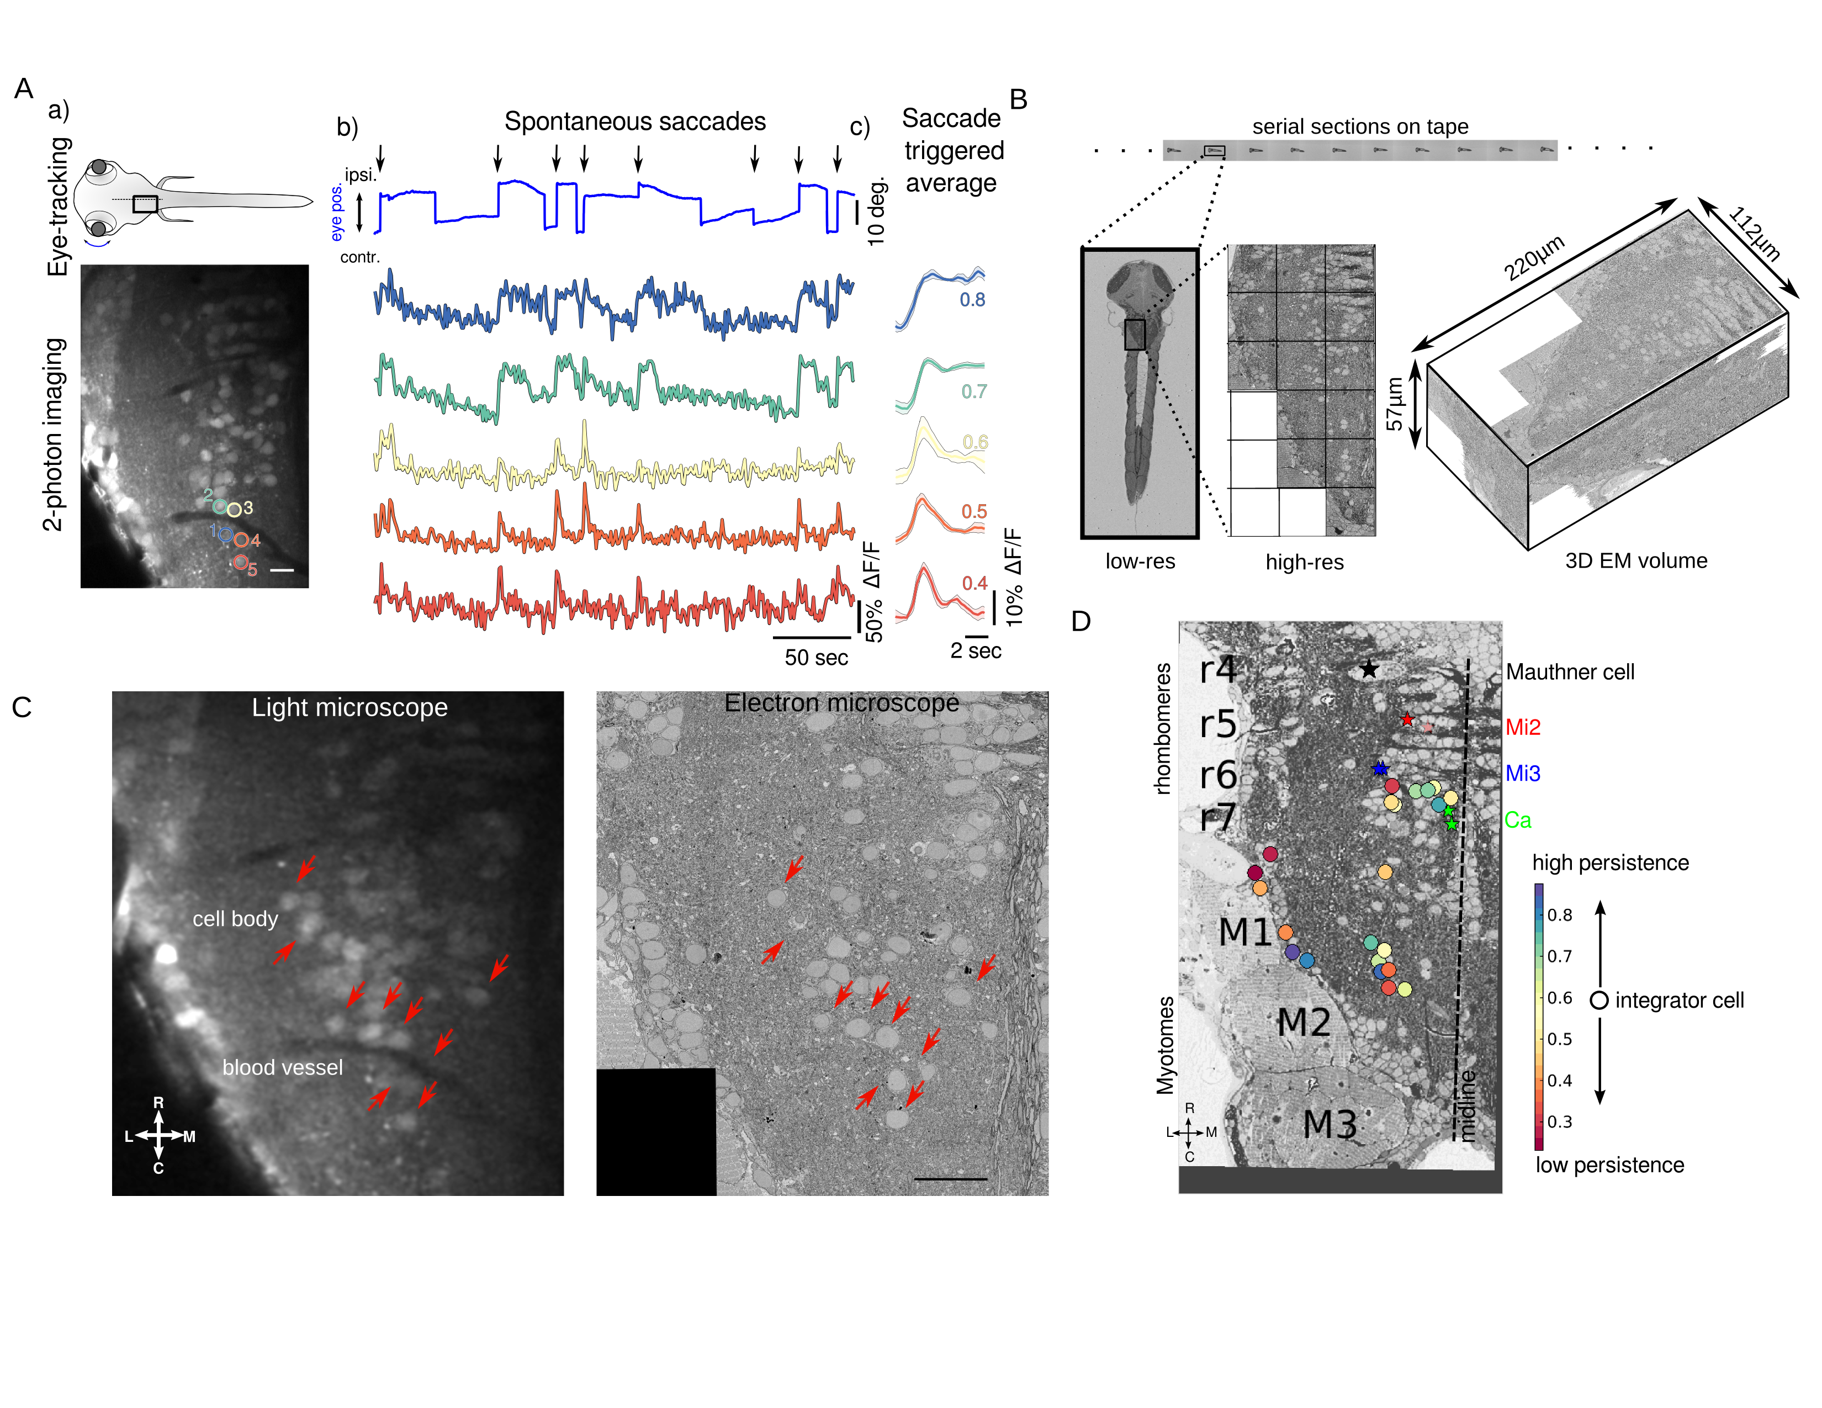

Figure 1: Functional and structural imaging of integrator cells.

(A) (a) Top - Larval zebrafish schematic showing the region around which functional imaging was performed (black box) located in the hindbrain, and eye-tracking.

Bottom - A single imaging plane showing cells loaded with calcium indicator OGB-1. Integrator cells identified are show in colored circles. Colors reflect the level of persistence of the cell. Scale bar 20:*m*

(b) Spontaneous eye movement (blue) showing saccades (vertical lines) and post-saccadic fixations (horizontal lines). Ipislateral saccades are show with black arrows. Colored traces are the changes in fluoresence from individual cells from (a). Color coding reprensent the persistance level of the cell.

(c) Normalized fluorescence response following saccades. Thick line shows the normal, with shaded region showing the SEM. Numbers, are the avareages of the normalized fluoresence responses, a measure of persistence of the cell.

(B) Serial electron microscopy of same zebrafish from A, serial-sections are collected on tape in an automated manner, images at low-resolution are used to align the sections, imaging at high-resolution over the defined region of interest (black box) gives final 3D-EM volume of the imaged area.

(C) Registration of LM volume to EM volume to locate the cells that were involved in the behavior. Red arrows indicate the same features in both LM and EM. Scale bar 20:*m*

(D)Anatomical location of all integrator cells (circles) involved in the behavior along with anatomical landmarks, Mauthner cell, Mi2, Mi3 and Ca as identified in the EM volume (stars). Colors of the cells correspond to the persistence level of the cell.

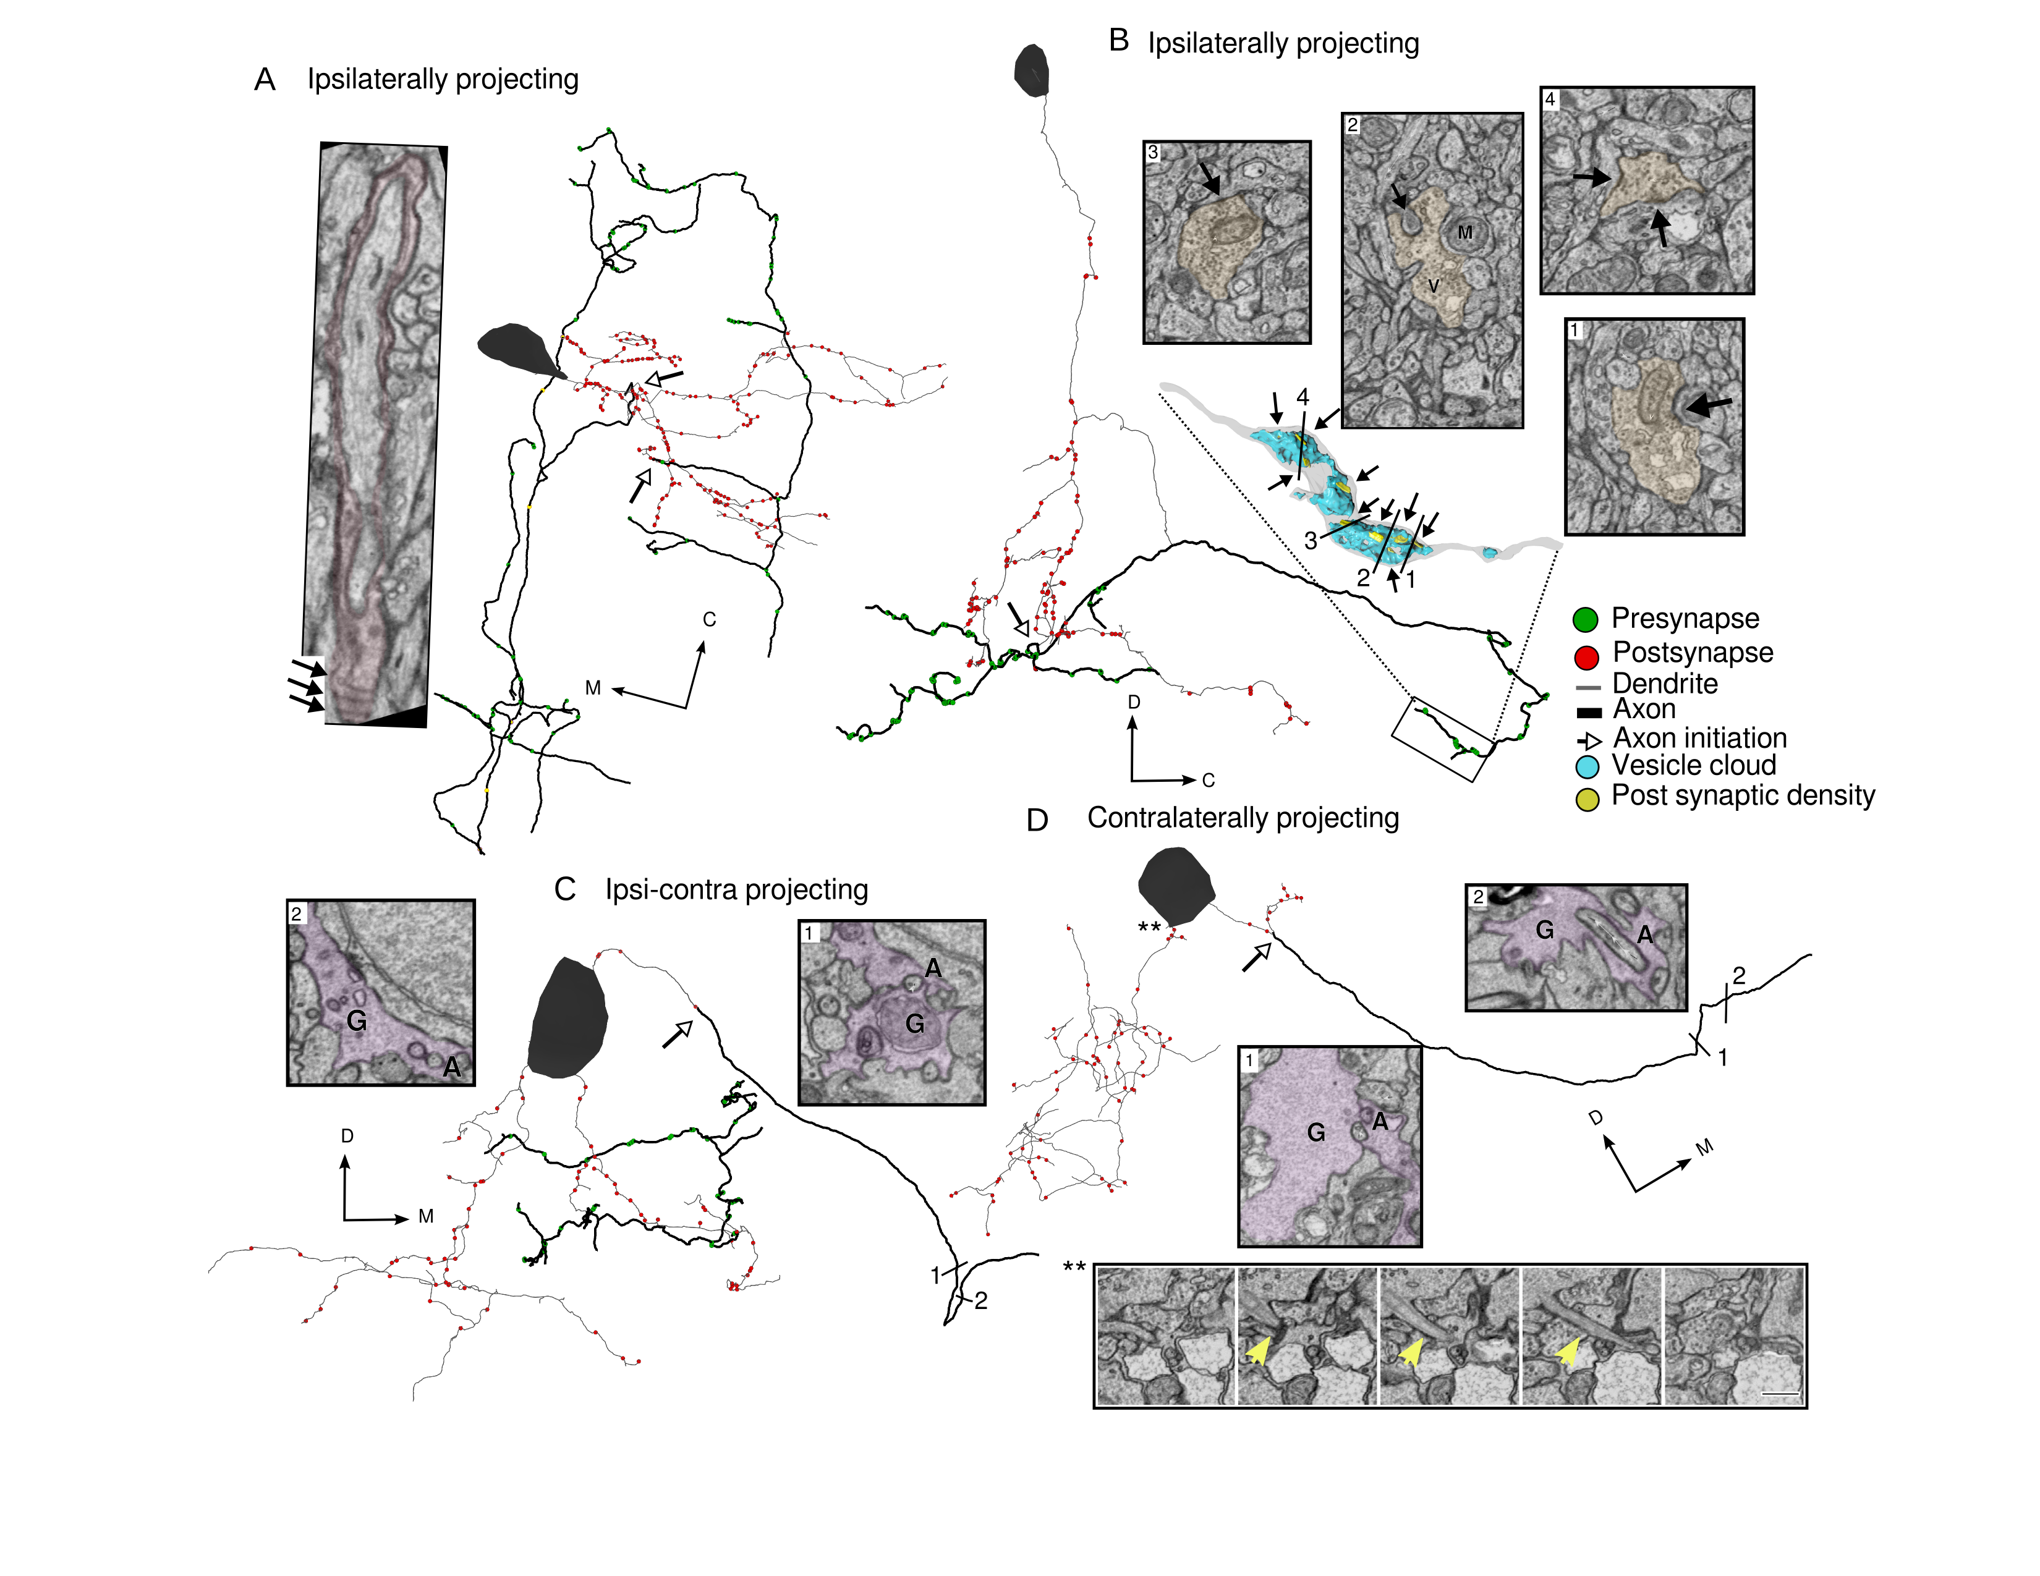

Figure 2: Integrator cell anatomical features reconstructed from EM volume.

(A) Example integrator cell showing ipsilaterally projecting axon (dark segment) and dendrite (light segment) with pre- (green circles) and postsynaptic (red circles) locations. Parts of the axon of this integrator cell are loosely-myelinated (colored boxes). Insets show one such myelinated region, with arrows showing individual myelin sheaths that are oblique to the imaging plane. Open arrow heads show the location of axon initiation zones along the neurite.

(B) Integrator cell, with ipsilateral projecting axon that starts as single neurite that branches to give rise to axon and dendrites. Axon is studded with presynaptic sites that are clustered along neurite. Inset is a 3D reconstruction of axon termination zone with a large vesicle cloud (blue) with multiple post synaptic densities (yellow) opposed to the vesicles. Numbers correspond to EM insets showing the synapses. M - Mitochondria, V - Vesicles. Arrows show the synapses at those locations.

(C) Example integrator cell with both ipsi and contralateral projecting axon. Putative contra axon is engulfed by glial process just before crossing the midline. Number correspond to EM insets with colored segments that are glia G, and non-colored segment is axon A. Open arrowhead shows the axons initiation site.

(D) Contralaterally projecting integrator cell with putative axon crossing the midline with glial engulfment (EM insets at numbered locations G - Glia, A - Axon). Bottom EM inset panel shows primary cilium highlighted with yellow arrow. Note all the integrator somata in this volume give rise to a cilium, but it is shown for this cell.

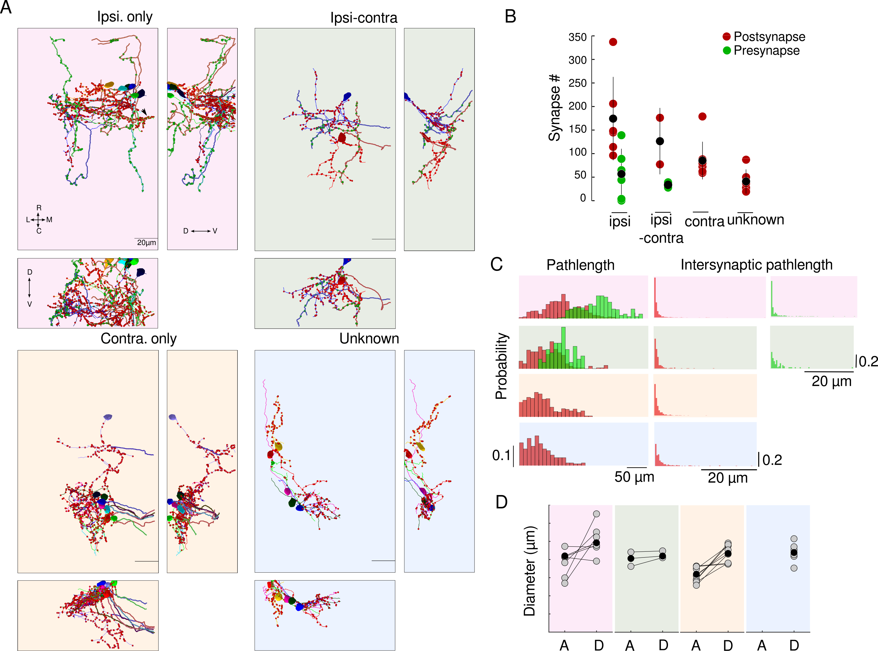

Figure 3: Integrator cells have distinct axonal projection patterns.

(A) Colored panels show three views of reconstructed cells with same axon projection patterns. Top left, 6 integrator cell with ipsilateral projecting axons - ipsi-only group, pink background. Top right, 2 integrator cells with ipsilaterally and putative contralateral projection – ipsi-contra, green background. Bottom left, 8 integrator cells with midline crossing contralateral only putative-axon – contra-only, orange background. Bottom right, 7, integrator cells with unknown axonal projection – unknown, blue background. On the neurites, red circles - postsynaptic sites, green circles - presynaptic sites.

(B) Number of synapses from each group. Black circle is the mean.

(C) (left) distribution of synaptic pathlength for all groups. (right) distribution of intersynaptic distance for all groups. (D) Axonal and dendritic diameter of all cells in each of the four groups. Grey dots are averages for each cell and black dots are averages per group. A - Axon, D - Dendrite.

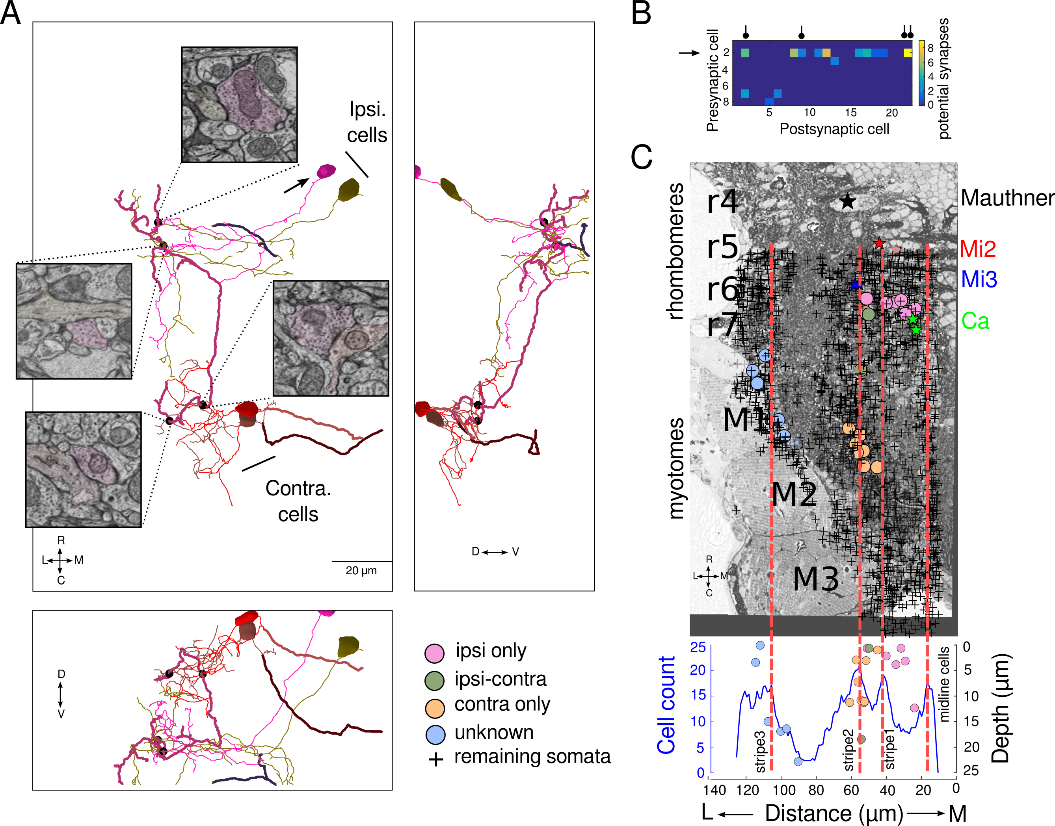

Figure 4: Integrator cells are synaptically connected.

(A) Heat map showing the spatial location of the presynapses and postsynapses of all integrator cells. White circles are the locations of the cell somata.

(B) Three views of synaptically connected integrator cells. All synapses were from one cell (magenta, arrow) in ipsi-only group onto one other cell from ipsi-only group (olive). One synapse each from ipsi-only group cell (magenta) onto two contra-only cells (red and brown). Black dots represent the location of the synapses, with insets showing the electron micrograph at the respective location. In all electron micrographs.

(C) Potential synapses that are <1:*m* from each other. Cell # 2 (arrow), is the same cell in (A, magenta) that makes maximum number of potential synapses onto other cells and makes the real synapses shown in (A). The real synapses are represented by the black circle in the header.

(C) Electron micrograph overlaid with all somata in volume (+ shape) and identified integrator cells (colored circles), and anatomical landmarks (colored stars). Lower panel is a distribution of all cells with integrator cells overlaid. Dotted line correspond with hindbrain stripes with known neurotransmitter identities.